Sonic Restaurants

Current Situation
Sonic Restaurants has been carrying out its business in 44 states out of the 50 states within America. However, the company is looking forward to establishing itself in the other remaining states. The company is seeking new ways through which it can increase its business while at the same time reducing the operation costs (Hoffman, 2017). The company is looking for a way that they can break away from the traditional way of doing business; the restaurants have been serving their customers at the comfort of their cars by roller-skating carhops.
Following the recession period in 2008, the restaurant was affected negatively in such a way that it held-up some of its plan for expansion; for instance, it postponed the establishing of a restaurant in Alaska. However, the management is determined to continue doing business regardless of the tough economic conditions. They have promised to open 1000 drive-ins by 2024 (Hoffman, 2017).
Past Performance
The restaurant's growth or rather a performance has been tremendous since it kept on increasing its revenue with every joint it opened. The company kept on expanding its operations from the small town of Oklahoma to Kansas, Arkansas, Missouri, and New Mexico. Since 1967 to 1978 the company increased the number of drive-ins from 41 to 1000. In 1991, the company started to open between 100 and 150 new drive-ins, and by 1998, the company had more than 1700 restaurants. Additionally, in 2003, Sonic Restaurants had opened more than 3000 drive-ins and introduced card readers in the parking lots so that they could increase their efficiency in the way they operated (Hoffman, 2017).

Strategic Posture
Sonic Restaurants was envisioned to become the premier drive-in restaurants that many Americans had been looking for. It has been carrying out its business successful, and it deals with fast food such as hot dogs, hamburgers, and sandwiches among others (Hoffman, 2017). Also, the corporation has come up with a highly customizable and adaptable design that suits indoor dining which is best during the cold weather times.
Mission
The mission of Sonic Corporation is to become the most loved restaurant brand in America.
Objectives
The core objective of Sonic Company is to grow through the opening of many drive-in outlets. The company has resulted in adding more stores through franchising.
Strategies
- One of the key strategies of Sonic Corporation is expansion into small towns.
- Another strategy through which the company has become famous is through similar branding of all outlets including the franchise drive-ins.
Policies
Sonic has got a set of policies that deal with the conduct of employees and also policies regarding how the personal data of the customers should be treated. Personal information should be guarded and not given to an unauthorized person.
Corporate Governance
Board of Directors
Paul Brown, Nils H. Okeson, and David Pipes.
Top Management
Claudia San Pedro (president); Paige Bass (Senior vice president and general council); E. Edward Saroch (senior vice president of franchise relations); Lori Abou Habib (vice president and chief marketing officer); and Corey Horsch (vice president (VP), chief financial officer, and treasurer).
External Environment
Economic
Sonic Corporation started off well, and it reached a point where it started operating franchise; operating with other people's money. This helped the corporation in maximizing the profits that that was reported at the end of each trading period. In 2008, the corporation was hit by the economic recession that hit the US economy and the entire global economy; it did not make the amount of profit which it had been making in the past trading period (Hoffman, 2017). However, it made profits that would help in the meantime. After the recession was over, the corporation has been running and is determined to becoming successful within the US and even in other regions.
Technological
Sonic Corporation has embraced technology in its running. The corporation has a POS (point of sale) where the management of the company can track data regarding sales. In the default state, the POS serves as a point where customers can place orders and at the same time as a platform for promotions. Additionally, there has been new technologically sophisticated supply chain management that has helped in increasing the efficiency of the services in such a way that it has cut down costs (Hoffman, 2017). The management of the corporation can now trace inventory that is in the form of packages and food.
Political/Legal
Sonic Corp. helps the company is looking into the different political environment and political system risks. Before establishing a drive-in join in any country or place it considers factors such as:
- Political instability.
- Risk of military invasion.
- Corruption level
- Government interference with the restaurants
- Favored trading partners among others.
Sociocultural
Sociocultural affect the culture of an organization. Every community has its shared beliefs and attitudes and helps in shaping how sonic marketers will understand customers in a certain market and hence coming up with the design of marketing message that will favor the restaurants (Hoffman, 2017). Thus, the marketers will look for factors such as leisure interest, class structure, and power within the society, education level, and attitudes.

Task Environment
The threat of New Entrants
There were other restaurants that were in the business of fast food business. Some of the biggest competitors of Sonic Restaurant were McDonald's, Subway, Starbucks, Wendy's, and Burger King. These competitors’ deals serve breakfast, lunch, and dinner, plus other franchised coffeehouses.
Power of Buyers
The consumers exerted pressure to Sonic Corporation since they always wanted to be provided with high-quality products, better services and at a lower price. The bargaining power of the buyers affected the profitability of the businesses that were carried out by Sonic Corporation. The buyers were stronger and required the drive-ins to be effective, and thus Sonic Corporation had to install check-in cards among other technologies to increase its efficiency (Hoffman, 2017). This installations of all these technologies cost the company a substantial amount of its profits.
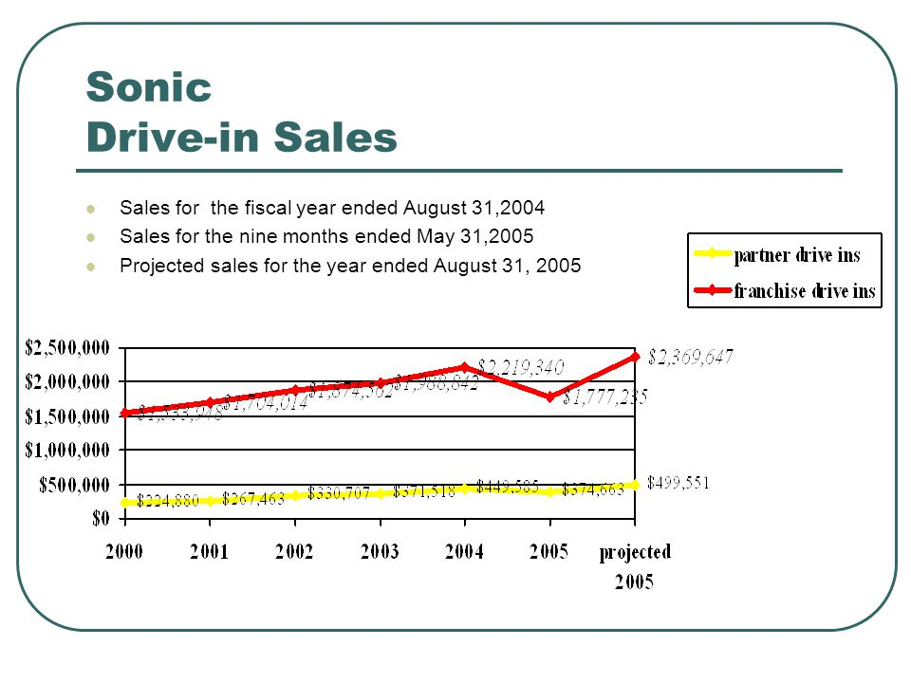
https://slideplayer.com/slide/4712784/15/images/52/Sonic+Drive-in+Sales+Sales+for+the+fiscal+year+ended+August+31%2C2004.jpg
The threat of Substitute Products
Within the fast food industry there existed other companies such as Starbucks, MacDonald's among others who dealt with similar products to those of Sonic Restaurants. Thus, they were competing for buyers in the market with Sonic Restaurants. The threat of substitutes affects the competitive environment for the companies operating in the same industry and also impacts the profitability of the services and products offered (Hoffman, 2017). This is because buyers can choose to buy from one food inlet and not the other.
Power of Suppliers
The suppliers who supply Sonic Restaurants can decide to increase the prices, lower quality or even reduce the availability of what they supply. Thus, the power of suppliers influences the competitive environment for the buyer and also the profit that the buyer will earn. In the past Sonic Corporation had been using codes that were not uniform and thus it kept on delaying its orders (Hoffman, 2017). However, it introduced universal codes which were shared across all centers, and this increased its efficiency. They were able to forecast demand which gave them an advantage of knowing which suppliers to negotiate with.
Rivalry among Competitors
Within the fast-food industry, there are a number of companies who compete with Sonic Restaurants and hence ends up exerting pressure on its profit potential. The rivals tend to compete in order to earn more profits and also grab for themselves a larger market share.
Power of Other Stakeholders
The other stakeholders do have an impact on the firm, and they include employees, shareholders, the public and the government. The government has the power since it is through it that the different businesses are licensed and also it collects taxes.
External Factors Analysis Summary (EFAS)
Opportunities | Weight¹ | Rating² | Weighted Score³ | Comment⁴
Food menu | 0.3 | 5 | 1.5 | Can be broaden.
Introduce new adaptable business models | 0.2 | 5 | 1.0 | New models that can work in towns.
Partner with other players in the sector and outside. | 0.2 | 4 | 0.8 | Non-core markets.
Threats
Stiff competition | 0.2 | 3 | 0.6 | MacDonald’s offers a variety of foods at reasonable prices
New entrants | 0.1 | 2 | 0.2 | It is not costly to start a fast food joint.
Total | 1.0 |  | 4.1

Internal Environment
Marketing
The company has been working on how it can become America's iconic drive-in within the region. There has also been franchising as a means of enabling other people to operate under their name which has really helped in making its name known in many areas. Additionally, they have resulted in negotiating with the real estate developers on the design and selection of the construction site. Sonic also ensured that its stores or rather drive-ins were branded in a similar way so as to enhance its brand; it created brand consciousness (Hoffman, 2017). The corporation must have wanted to choose prime locations so that they can run businesses successful. Also, Sonic has increased the amount of money that it has been allocating to media advertisements so that they can reach out to many consumers as possible.
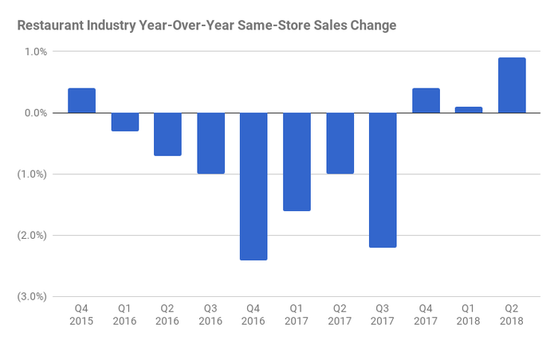
https://g.foolcdn.com/image/?url=https%3A%2F%2Fg.foolcdn.com%2Feditorial%2Fimages%2F495355%2Fchart.png&w=700&op=resize
Finance
Sonic Corporation has been making a high amount of sales. The company makes a high amount of sales in its own drive-ins as well as in the franchise drive-ins. For instance, the year before 2015 the company made 73% sales in its own drive-ins and 27% in the franchise drive-ins. In addition, the company has been experiencing high sales even in previous years (Hoffman, 2017). For example, Sonic made sales amounting to $542.6 million in the fiscal year 2013 and $552.3 million in the fiscal year 2014. This shows that the company kept on increasing its sales.
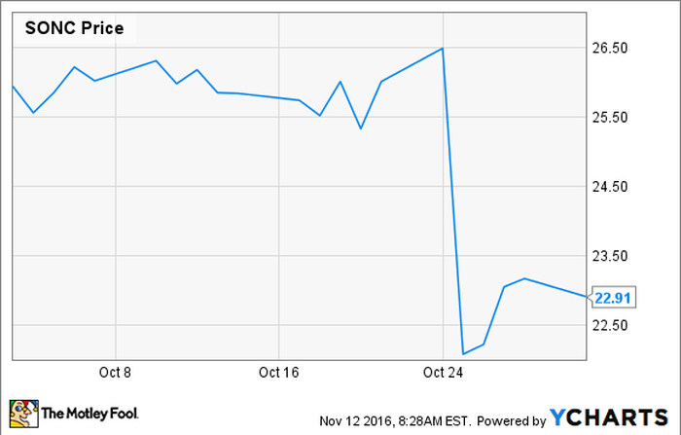
https://g.foolcdn.com/image/?url=https%3A%2F%2Fg.foolcdn.com%2Feditorial%2Fimages%2F419250%2Fgenerate_fund_chart.png&w=700&op=resize

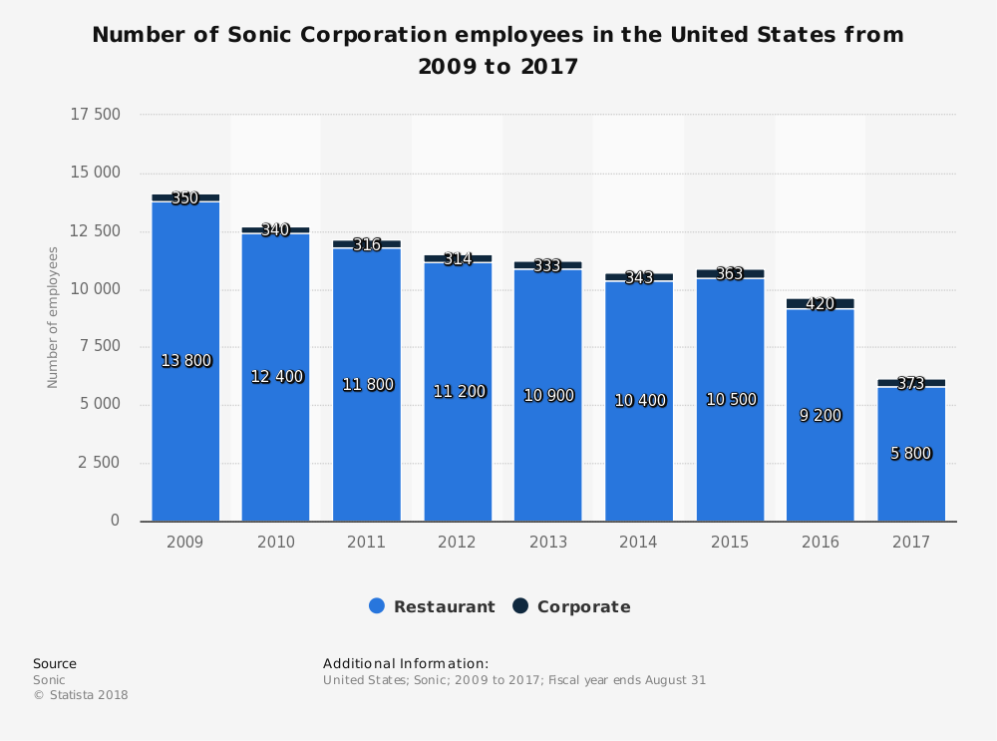
https://www.statista.com/graphic/1/302844/number-of-sonic-corporation-employees-us.jpg

R&D
Sonic Restaurants have used R&D in ensuring that they were a step ahead of their competitors within the market. Sonic Corporation has used roller skating carhops in increasing the efficiency with which the customers are served. Once customers drives-in the parking ground of the various joints it is not a must they come out of their cars, they just need to make an order, and then they are served through the carhops.

Operations and Logistics
Sonic Restaurants have been branded in a similar way which has helped it in creating brand awareness. Its operation is customized such that the customers enjoy their experience once they visit Sonic's drive-ins. However, the franchises represent a risk of not replicating the exact image of the parent company. On the other hand, Sonic has over 3000 stores of which are located in different states, and sometimes they require to transport goods from one place to another and due to this factor they have a problem with availing of goods in time (Hoffman, 2017).
Human Resources
Sonic's human resources department is working on bringing on-board some of the most talented and renowned professionals who have occupied some of its crucial offices. In 2014, Sonic employed 25 key personnel among them including Clifford Hudson who is the company's CFO (Chief finance officer). This has helped in ensuring the efficient running of the company. Talented and professionals with experience help in ensuring top notch relations with customers and streamlining the processes within the different departments of the company (Hoffman, 2017).
Information Systems
Sonic Restaurants have not been left behind by the technological innovations that have happened within the information systems. Sonic acquired a POS (Point of sale) that enabled it to collect data and also helped in placing of orders among the customers. Also, Sonic employed the use of new codes whereby it could make orders from their suppliers. Due to the data that was availed by the new information systems that linked the company with its suppliers, it was possible for the management to predict demand and hence make proper arrangements on how to acquire certain supplies (Hoffman, 2017). Also, it gave the management a chance to engage the right supplier in negotiation so that it could influence the pricing of the supplies and hence the profits that it earned at the end of every fiscal year.
Internal Factor Analysis Summary (IFAS Table)

External Factors | Weight¹ | Rating² | Weighted Score³ | Comments⁴
Strengths
Financial position | 0.15 | 5 | 0.75 | Profitable, too many assets.
Information management | 0.05 | 4 | 0.20 | Well-designed POS.
Human resources | 0.10 | 4 | 0.40 | Well-connected with the most renowned professionals.
Operations and logistics. | 0.05 | 3 | 0.15 | Operations are customized to maximize customer’s experience.
R&D | 0.1 | 3 | 0.3 | Ensures company is a step ahead its competitors.
Weaknesses
Drive-ins model | 0.5 | 2 | 1.0 | Only applicable in warm climate areas.
Drive-ins can only operate in places with large parking areas. | 0.25 | 2 | 0.5 | Drive-ins works well in outskirts of towns.
High media costs. | 0.25 | 2 | 0.5 | Does most of its promotions in media.
Total Score | 1.0 |  | 3.80

Strategic Factors
SWOT Analysis
Strengths
- Sonic Restaurants enjoys quick services which result from the use of a speaker and microphone-based carhop servers and the ordering systems (Hoffman, 2017). They at times serve using the roller skates.
- Sonic derives its success of franchise from the use of information technology.
- Sonic has unique quick service and a customized menu which has helped it in standing out from the crowd.
- Sonic has strong management and human resources policies which have helped in shaping its operations within the different departments.
Weaknesses
- The business model that the drive-ins offer is only applicable in areas with a warm climate.
- The drive-ins can only operate in areas with large parking lit which eliminates them from operating from city centers; they can work well in the outskirts of towns.
- Sonic incurs high media costs every year since it does most of its promotions or rather ads there.
Opportunities
- Sonic can broaden its food menu; they can include and offer even more food items since the more varieties they have, the more customers they will attract.
- They can develop new models which can work better in a big town that have small parking areas.
- They can partner and spread their services even to the non-core markets.
Threats
- Among the top competitors of Sonic company is MacDonald's, Wendy's and Burger King. Among these three competitors, MacDonald's poses the greatest threat since it offers a variety of foods at very reasonable prices.
- There is a threat of new entrants since the fast food industry does not require high capital to start.
Strategic Factor Analysis Summary (SFAS)
Strategic Factors | Weight¹ | Rating² | Weighted Score³ | Comments⁴
Expansion into small towns. | 0.5 | 4 | 2.0 | Small towns have sufficient areas where they can develop drive-ins.
Continue with similar branding | 0.25 | 3 | 0.75 | Has already a build a strong brand.
Increase franchise drive-ins. | 0.25 | 3 | 0.75 | Will keep on adding extra money.
Total Scores | 1.00 |  | 3.5

TOWS Matrix
Strengths  - Quick service.  - Use of technology.  - Customized menu.  - Strong management and human resource policies. | Weaknesses  - Drive-ins cannot operate well in urban areas.  - High advertisement cost.  - Drive-ins not efficient in cold climates.
Opportunities  - Broadening its food menu.  - Coming up with new models that can work better in urban areas.  - Partnering with non-core markets. | Threats  - Stiff competition from MacDonald’s since it offers a variety of foods at reasonable prices.  - Threat of new entrants since it is not costly to start a fast food joint.

Recommended Strategy
Sonic can integrate a system whereby it connects its POPS screen with a mobile user by name and suggests add-on items to the time of day. The system will track order progress and will alert the customer on the progress of the order. Also, this synchronization with mobile users will help the company collect data from the people who visit the stores which will, in turn, help them in developing additional content, new features and also fit the experience as trends keep on changing.
Functional Strategy
Sonic restaurants should keep on being unique in their provision of services to the customers. The company operates under its strategy which is value through differentiation.

Reference
Hoffman, A. N. (2017). Sonic Restaurants: Does Its Brive-In Business Model LimitFuture Growth Potential?

